Second Iteration Progress Report: mycheapfriend.com

# COMS 4156: Advanced Software Engineering

# Team: CheapSkates

## Team Members

## Double Trouble: Waseem Ilahi (wki2001@columbia.edu)

## Shaoqing Niu ([sn2385@columbia.edu](mailto:sn2385@columbia.edu))

## Dynamic Duo: Michael Glass (mgg2102@columbia.edu)

## Huning "David" Dai (hd2210@columbia.edu)

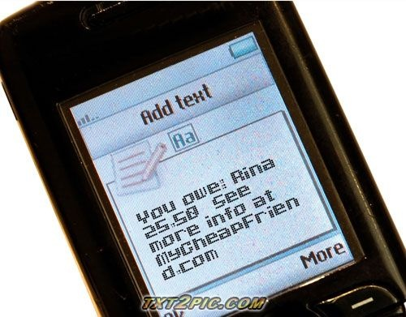

The **Cheapskates** from **MyCheapFriend.com** will lend you our **Progress Report,** if you give us back feedback soon.

# Unit Testing Report

# Code Inspection Meeting

We chose the class that implements most of the business logic for our system, to do the code inspection on it. The name of the class is Controller.java. The inspection took place in the Room 633 MUDD. The meeting started at around 11:45 am and finished around 12:20 pm. Since there was a lot of code in the “unit”, we could not go through all of the code in time; however, we got through the important functionality in time.

Michael Glass was the appointed reader and Waseem Ilahi was the recorder. And obviously the TA (Jonathan Bell) was the moderator; however professor Kaiser was also present at the meeting.

The logic of the code was all satisfactory and there was no problem with the code in that context. The TA went through the checklist to make sure each point was covered in the inspection. All the checkpoints were satisfied, except there was a little problem with the last two.

* Check for appropriate code comments (is code's behavior clear).
* Check for appropriate code factorization into atomic parts.

We found a little inconsistency in the code, in terms of the usage of “true” and false. Also there was one other rather large Boolean expression, that might confuse the reader (suggested the TA). There was also some concern with the comments and there placement. The last thing that the TA suggested was to divide the main “part/unit” of the inspected unit, into logical components.

From the code files attached with folder containing this document, we can see that the modified “unit” implements the changes suggested. A “diff” of the two sources will show the exact changes. The main method (handle()) is left as a few calls to other methods, that act as a fork to take the control over to the appropriate method to handle the feature the user wants to use. This process simplifies the main method and divides the entire logic into smaller pieces. As mentioned earlier, the changes can be seen in the file named “code_inspection_unit_modified.java”.

# Defect Log

# Controversies

There are no controversies among the group.

# Code

All the code and data is inside the zip file containing this document. The files are appropriately named and also contain documentation to state their purpose.

Files for Code Inspection unit:

1. code_inspection_unit_original.java
2. code_inspection_unit_modified.java